NEIS System
This is a system that is used by schools to regulate attendance amongst other things. Those of you who work in multiple schools, must check in and check out with your main school, before going to your next school. You will do so on this site.
If you go on a business trip, for example, there is a GOE workshop and you have received permission to be excused from school to come to the workshop, then you must apply through this website to be able to go on a business trip.
Essentially, this process used to be all paper and pencil, meaning you would have to receive permission physically by receiving signatures and such. However, through this website, everything is automated and so rather than physically visiting your principal to request a signature, you can apply online, and your principal/coteachers will check the application and sign off electronically.
1. Go to the website below, advised to bookmark this page as you may be using it often.
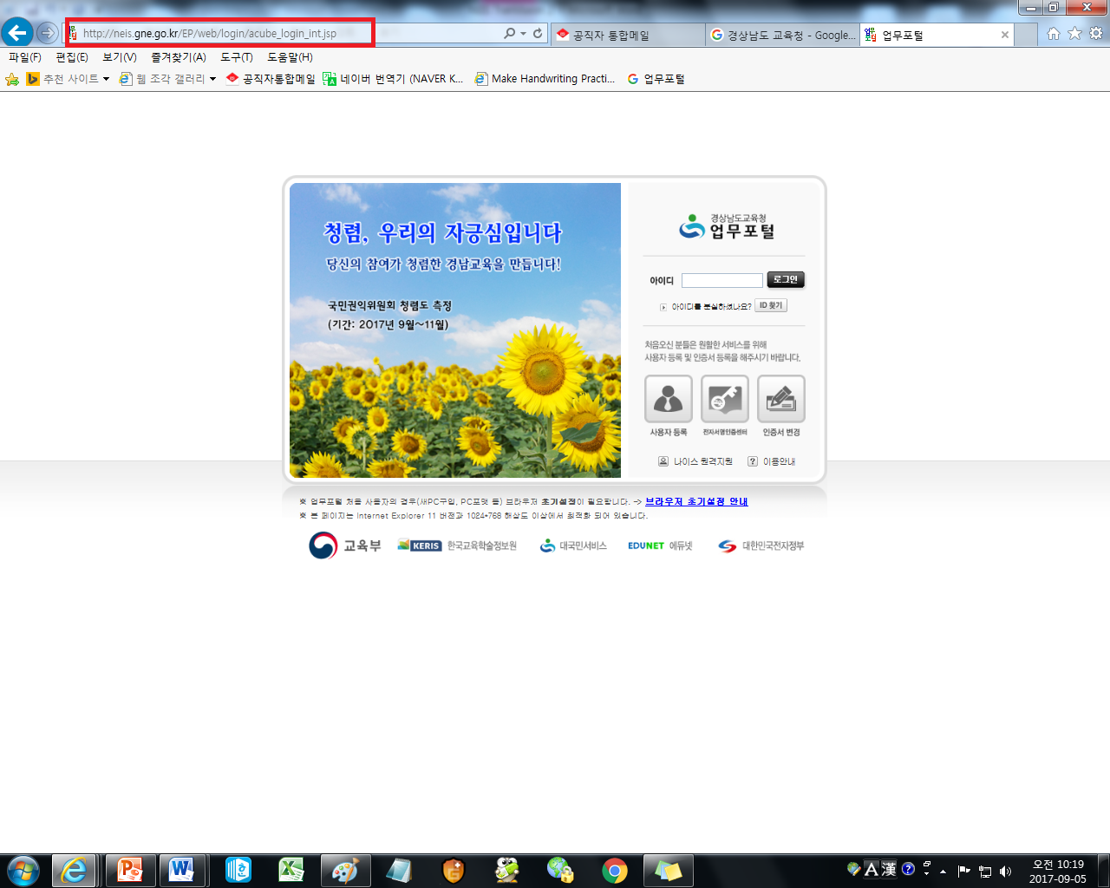

2. The website is called, 업무포털 (Up-Moo Po-Tal) – Work Portal
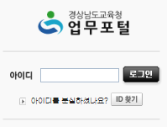
(On your first day, your school should help you to get started by setting up an account)
3. Enter in your ID (above), and you will then be prompted to type in your password (below).
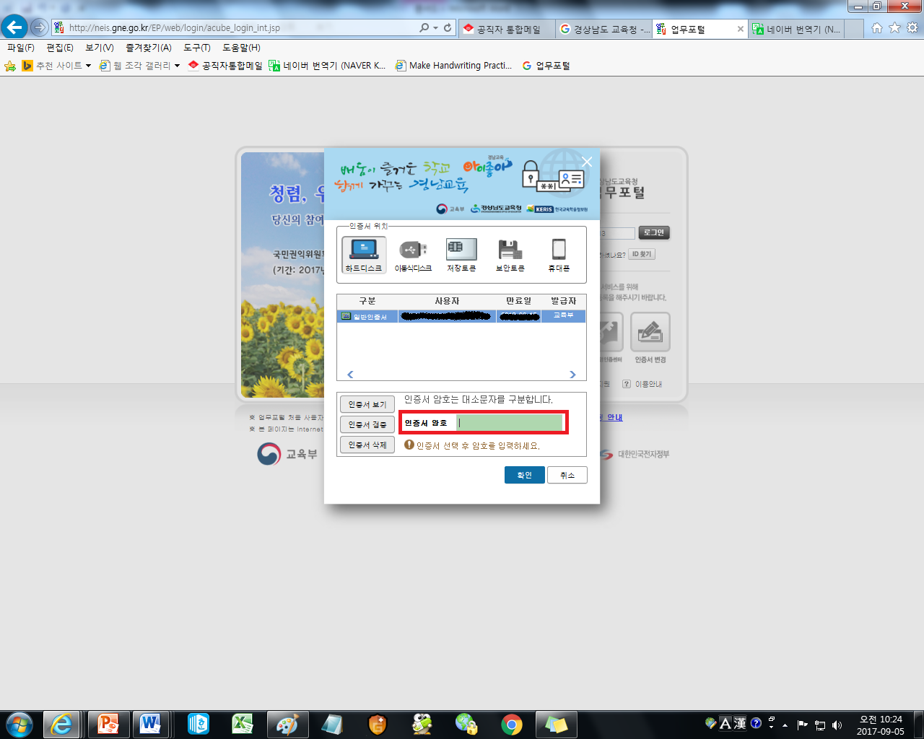

4. Once you have successfully logged on, you will be sent to the homepage. You can just x out of any popups that appear.
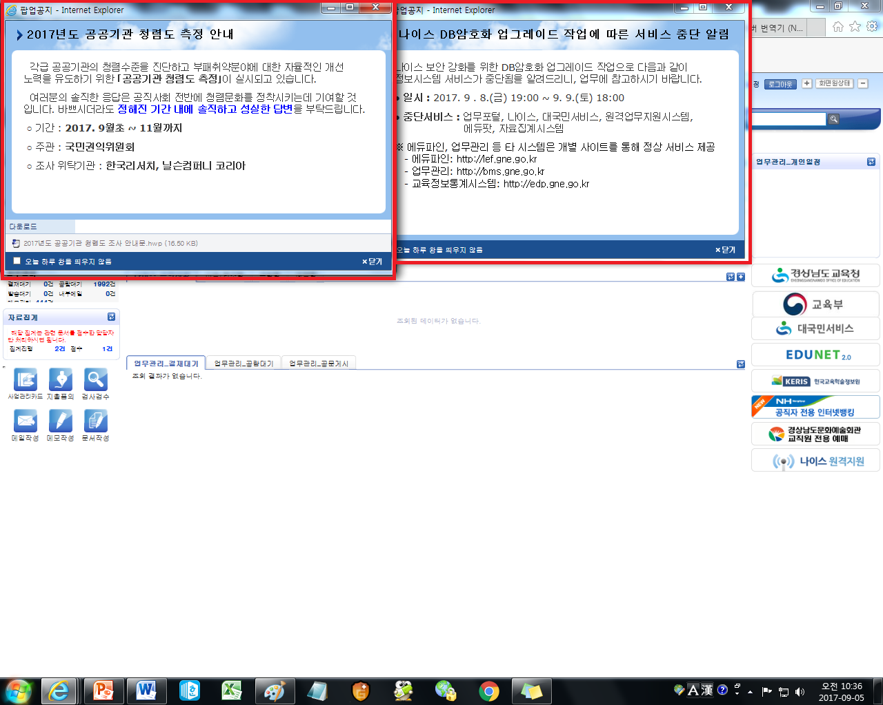

5. The 업무포털 homepage.
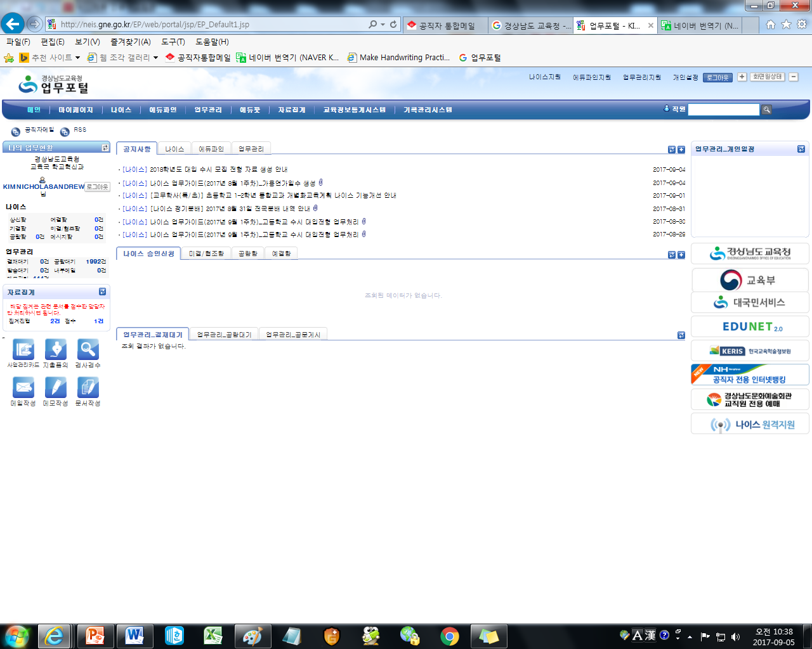

6. Through this website, you can do a lot of things such as send mail to teachers all over the GOE, however, our main purpose for this will be to mark attendance. So the next step will be to enter into the 나아스 (NEIS) system.
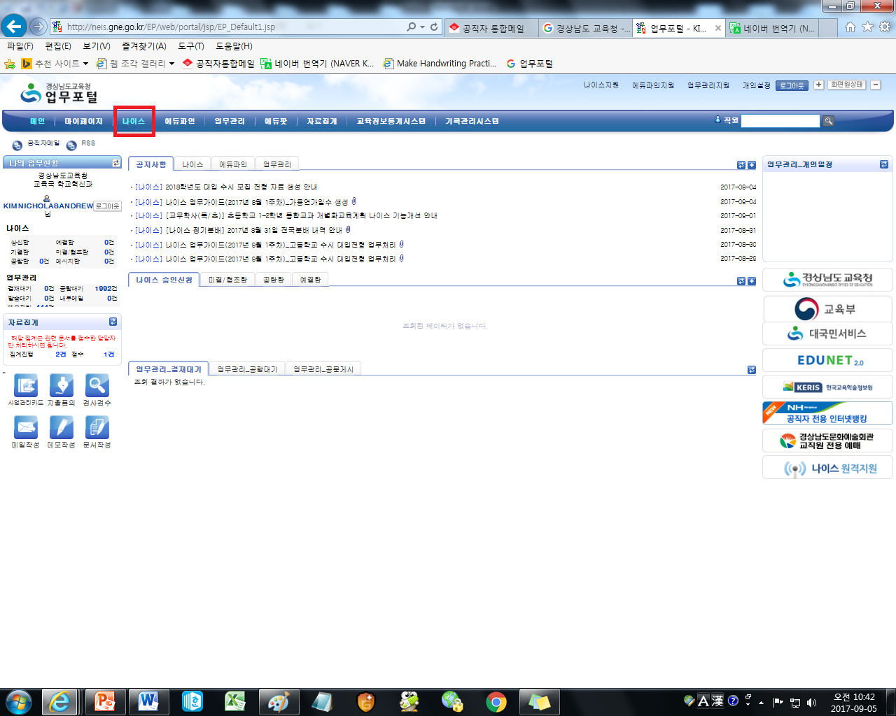

7. Clicking on 나이스, will bring you to this page. (Again, just x out of any popups that appear)
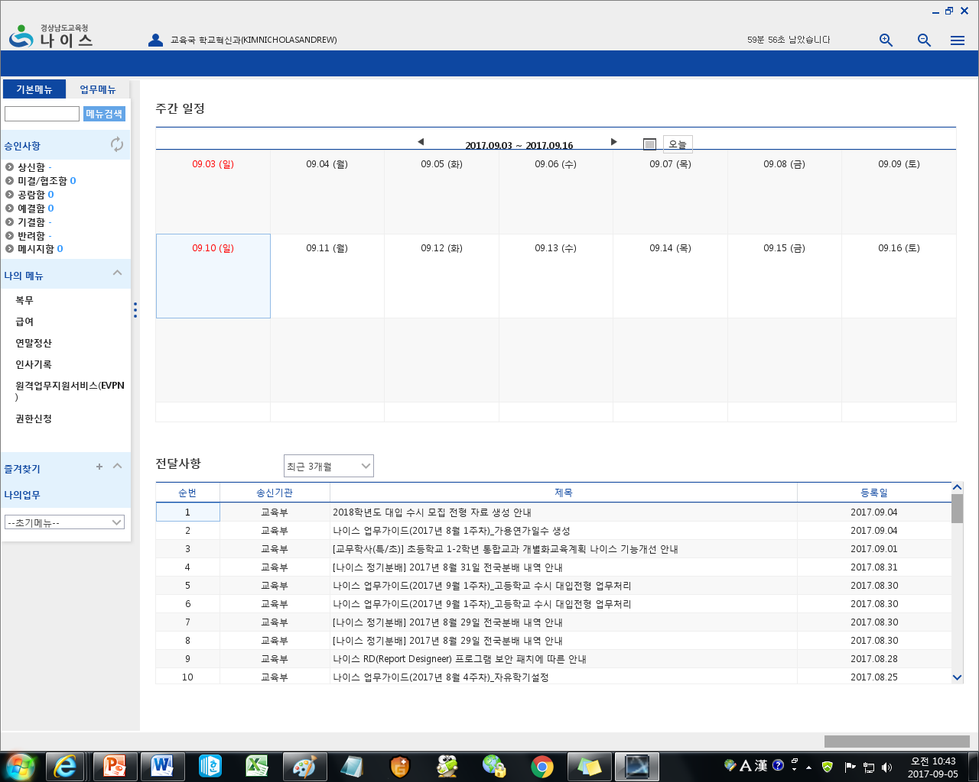

8. On the left-hand side, you will find a menu.
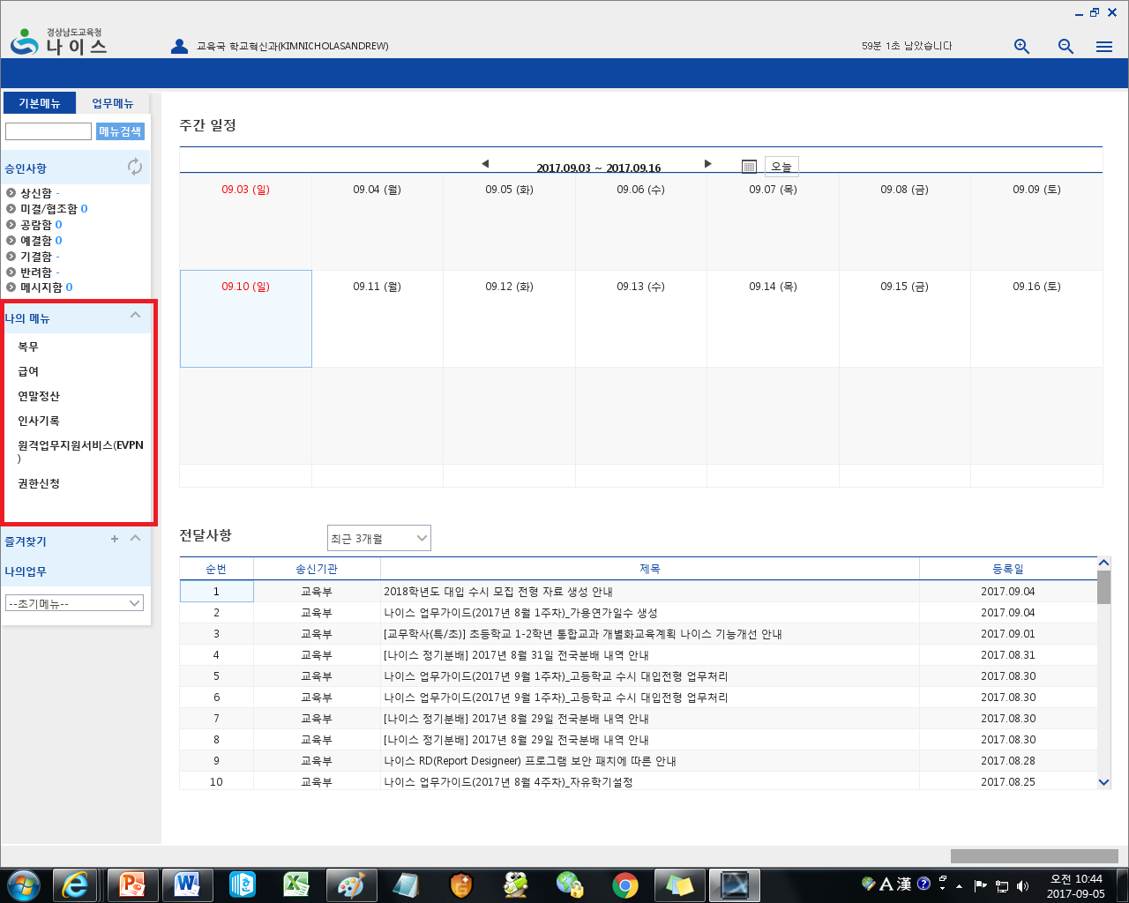

9. You want to click on the very first option entitled, 복무 (Bok-Mu) – service.
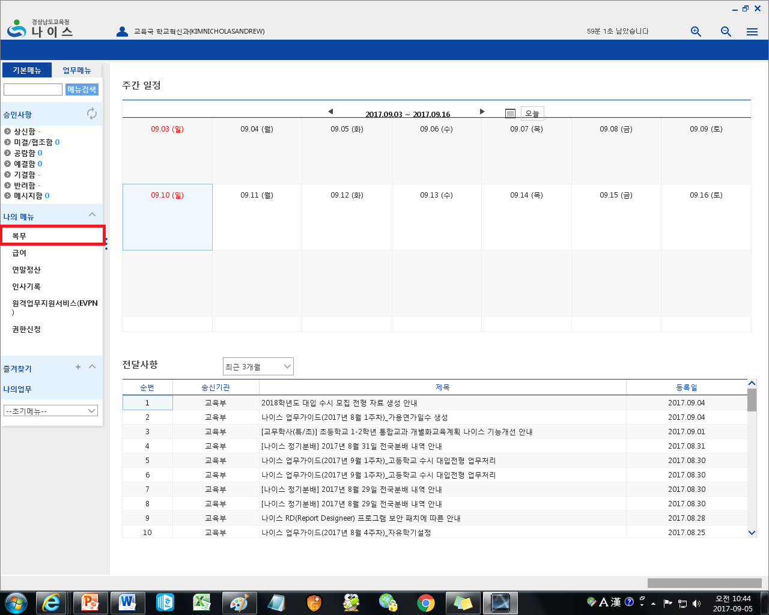

10. Clicking 복무, will reveal a longer list.
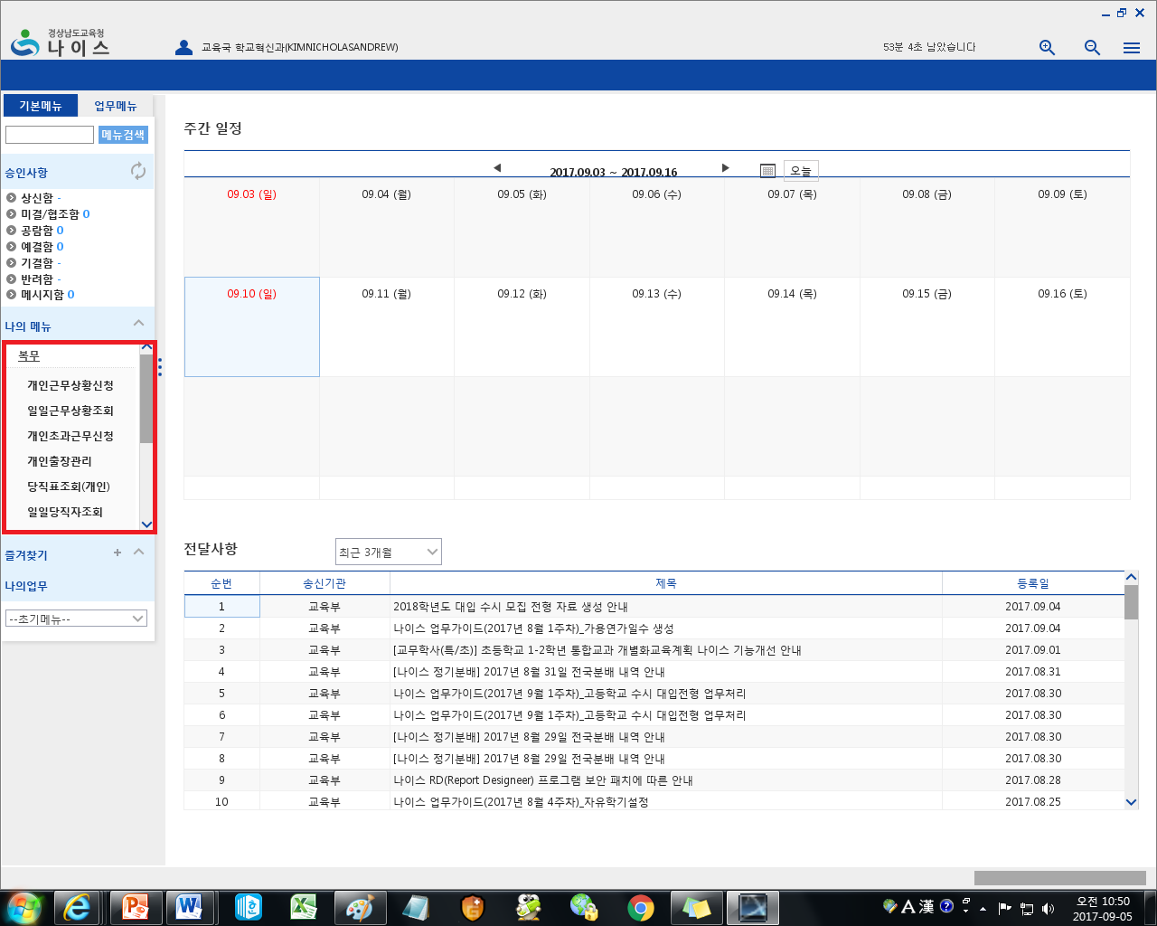

11. The two you will be using are
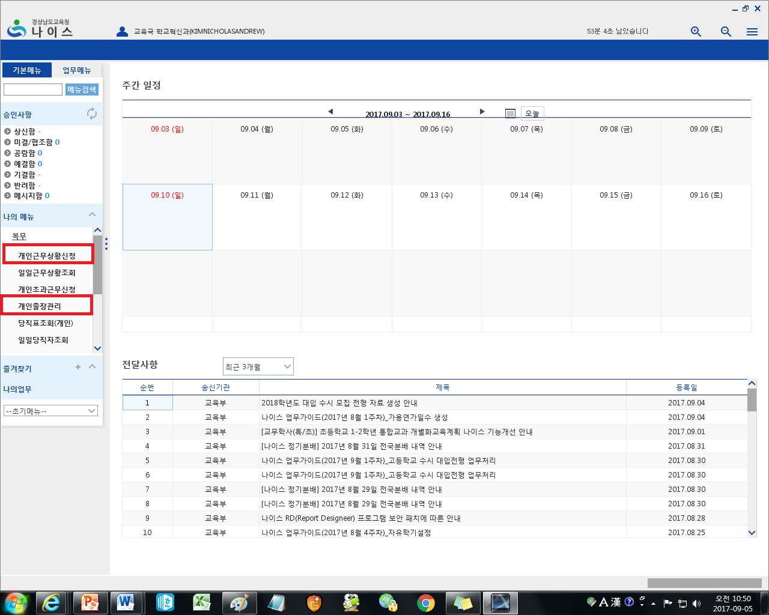
개인근무상황신청  (Geh-In Geun-Moo Sang-Hwang Shin-Chung)  Application for Personal Work-Related Events | This option is for pretty much all things related to attendence. If you have multiple schools, you need to sign attendence before going to your next school, you will do so here. When you go on a business trip within your area, for ex. you are a Jinju teacher. The Jinju office has a workshop for you to attend within Jinju, then you will sign up for a business trip through this. Sick leave, paid leave, special leave, early leave… etc, pretty much all things attendence will be taken care of here.
개인출장관리  (Geh-In Chool-Jang Gwan-Ri)  Managing personal business trips | This option is for business trips outside of your area. For ex. you are a Jinju teacher. The GOE has a workshop that is located in Changwon. As you are not a Changwon teacher, you must sign up for a business trip that is out of your area, so you will sign up here.

12. Let’s check out the first one, 개인근무상황신청. Let’s say you have multiple schools, 3 schools total. You attend your primary school Monday, Tuesday, and Wednesday. Thursday you go to your second school, and Friday you go to your third school. You will need to apply for non-paid business trip before you go from one school to the next and so you would first click on 개인근무상황신청. (Also, note you can apply for multiple business trips at once. In this situation as you are at your main school Mon, Tue, and Wed, you will need to apply for a business trip to your second school on Thursday AND a business trip to your third school on Friday. It is advised that you apply for all business trips at the beginning of the week, that way you don’t have to worry about it later on. Come Mon, just apply for both Thursday, and Friday, and you’ll be good. Below, we will talk about how to actually apply for business trips.

13. Clicking on 개인근무상황신청 will bring you to this page.
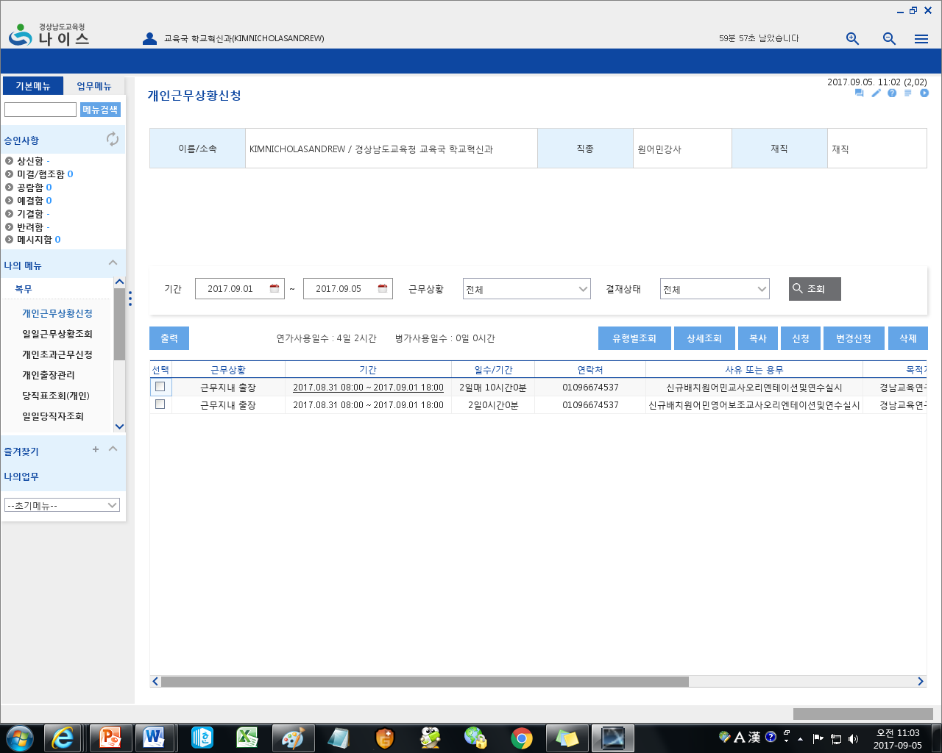

14. Here, you want to click on 신청 (Shin-Chung) – Apply.
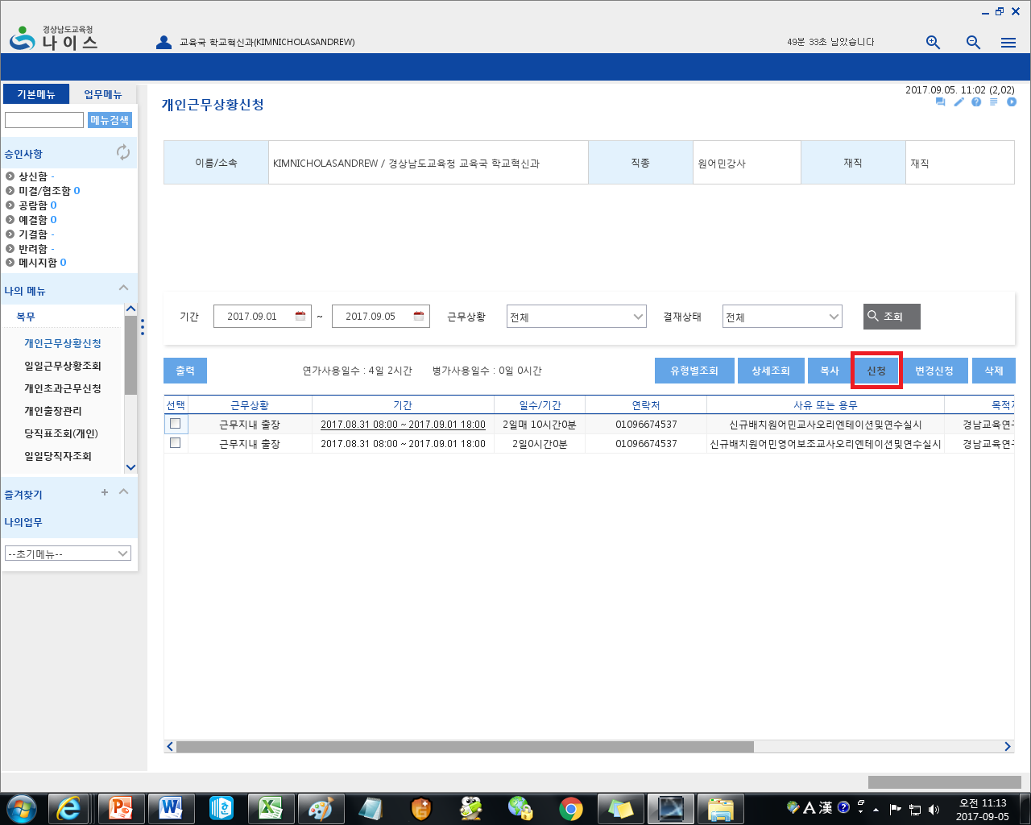

15. Clicking on 신청 will bring up this popup.
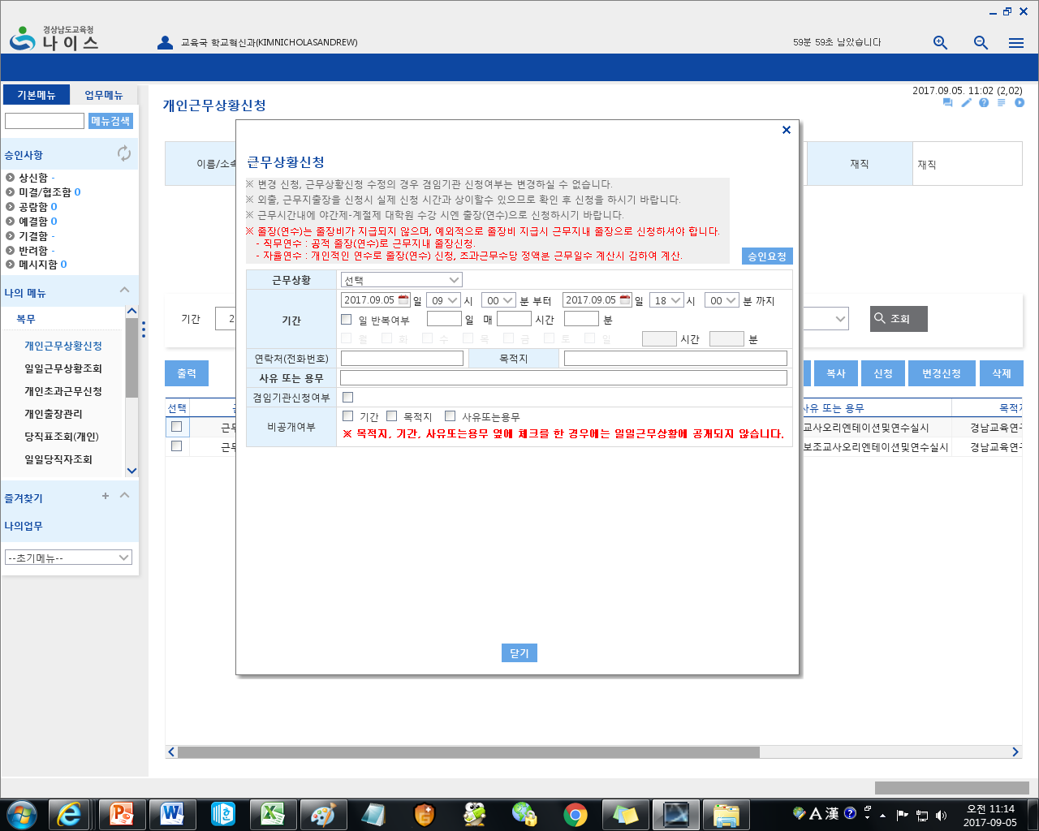

16. The first thing you will need to click is the arrow next to 근무상황 (Geun-moo Sang-Hwang) – Work Situation. Basically, what exactly are you applying for? When you click the arrow, a long list will appear.
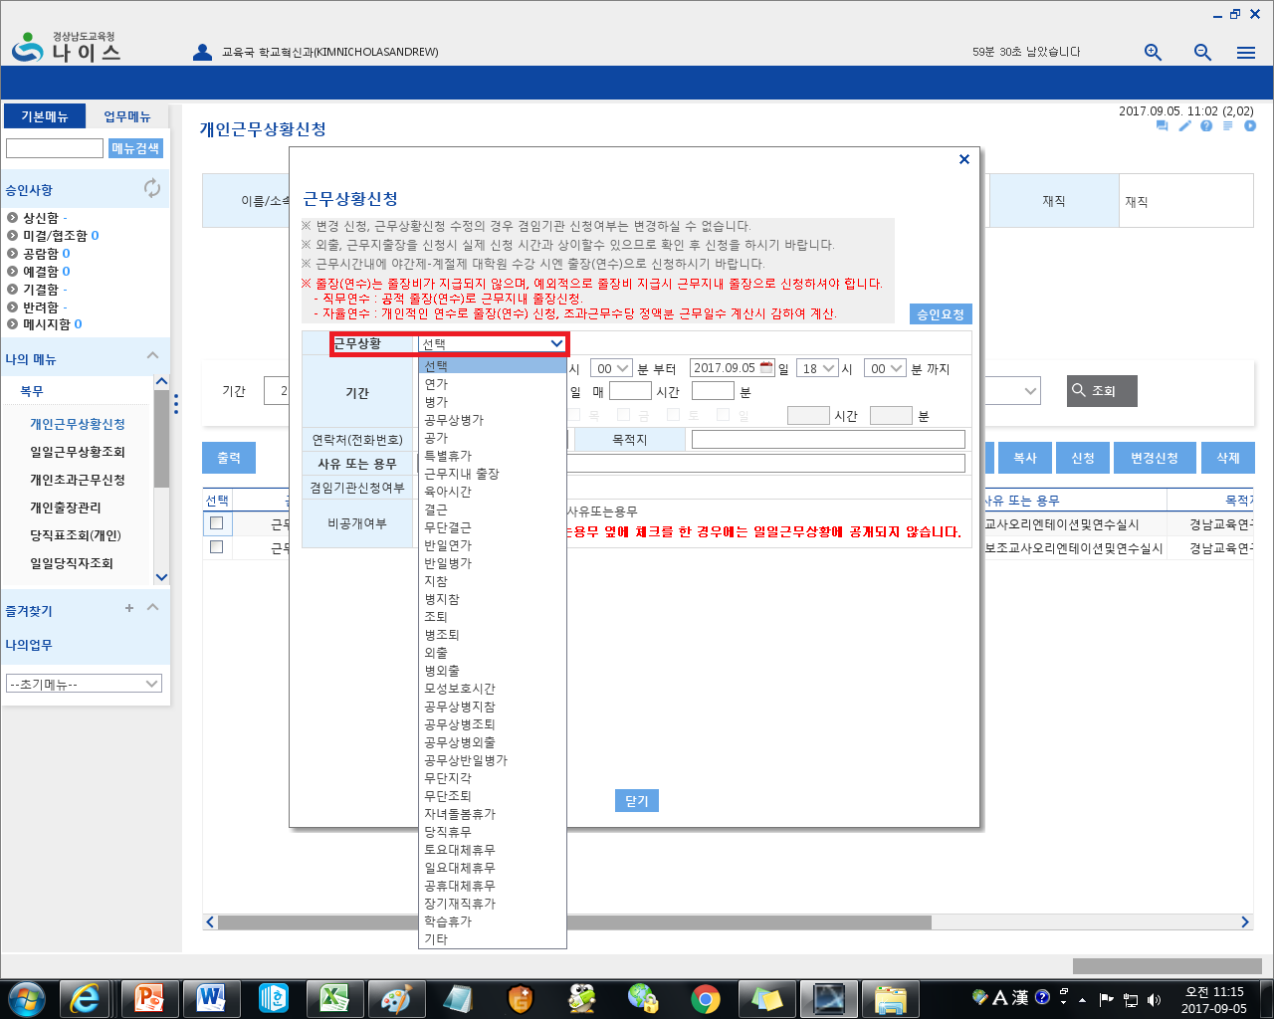

17. Here is a translation of the list.
 | Korea | Romanized | English
 | 연가 | Yeon-Gah | Paid Leave
 | 병가 | Byung-Gah | Sick Leave
 | 공무상병가 | Gong-Moo-Sang Byung-Gah | X
 | 공가 | Gong-Gah | X
 | 특별휴가 | Teuk-Byul Hyeu-Gah | Special Leave
 | 근무지내 출장 | Geun-Moo-Ji-Neh Chool-Jang | Business Trip (Within your area)
 | 육아시간 | Yook-Ah She-Gan | Maternity/Paternity Leave
 | 결근 | Gyul-Geun | X
 | 무단결근 | Moo-Dan Gyul-Geun | X
 | 반일연가 | Ban-Il Yun-Gah | Half-day Paid Leave
 | 반일병가 | Ban-Il Byung-Gah | Half-Day Sick Leave
 | 지참 | Jee-Cham | Being Tardy
 | 병지참 | Byung-Jee-Cham | Being Tardy due to illness
 | 조퇴 | Jo-Tweh | Early Leave
 | 병조퇴 | Byung-Jo-Tweh | Early Leave due to illness
 | 모성보호시간 | Mo-Sang-Bo-Ho She-Gan | Nursing Hour(s)
 | 공무상병지참 | Gong-Moo-Sang Byung Jee-Cham | X
 | 공무상병조퇴 | Gong-Moo-Sang Byung Jo-Tweh | X
 | 공무상병외출 | Gong-Moo-Sang Byung Weh-Chool | X
 | 공무상병일병가 | Gong-Moo-Sang Byung-Il Byung-Gah | X
 | 무단지각 | Moo-Dan Ji-Gak | X
 | 무단조퇴 | Moo-Dan Jo-Tweh | X
 | 자녀동봄휴가 | Jah-Nyuh Dong-Bom Hyu-Gah | X
 | 당직휴무 | Dang-Jik Hyu-Moo | X
 | 토요대체휴무 | Toe-Yo Deh-Cheh Hyu-Moo | X
 | 일요대체휴무 | Il-Yo Deh-Cheh Hyu-Moo | X
 | 공휴대체휴무 | Gong-Hyu Deh-Cheh Hyu-Moo | X
 | 장기재직휴가 | Jang-Gi Jeh-Jik Hyu-Moo | X
 | 학습휴가 | Hak-Seup Hyu-Gah | X
 | 기타 | Gi-Ta | Other (Holidays unique to your school, such as school bdays)

18. So going along with our example, we are applying for a business trip to go to our secondary school on Thursday. So in the list, you will be selecting 근무지내출장.
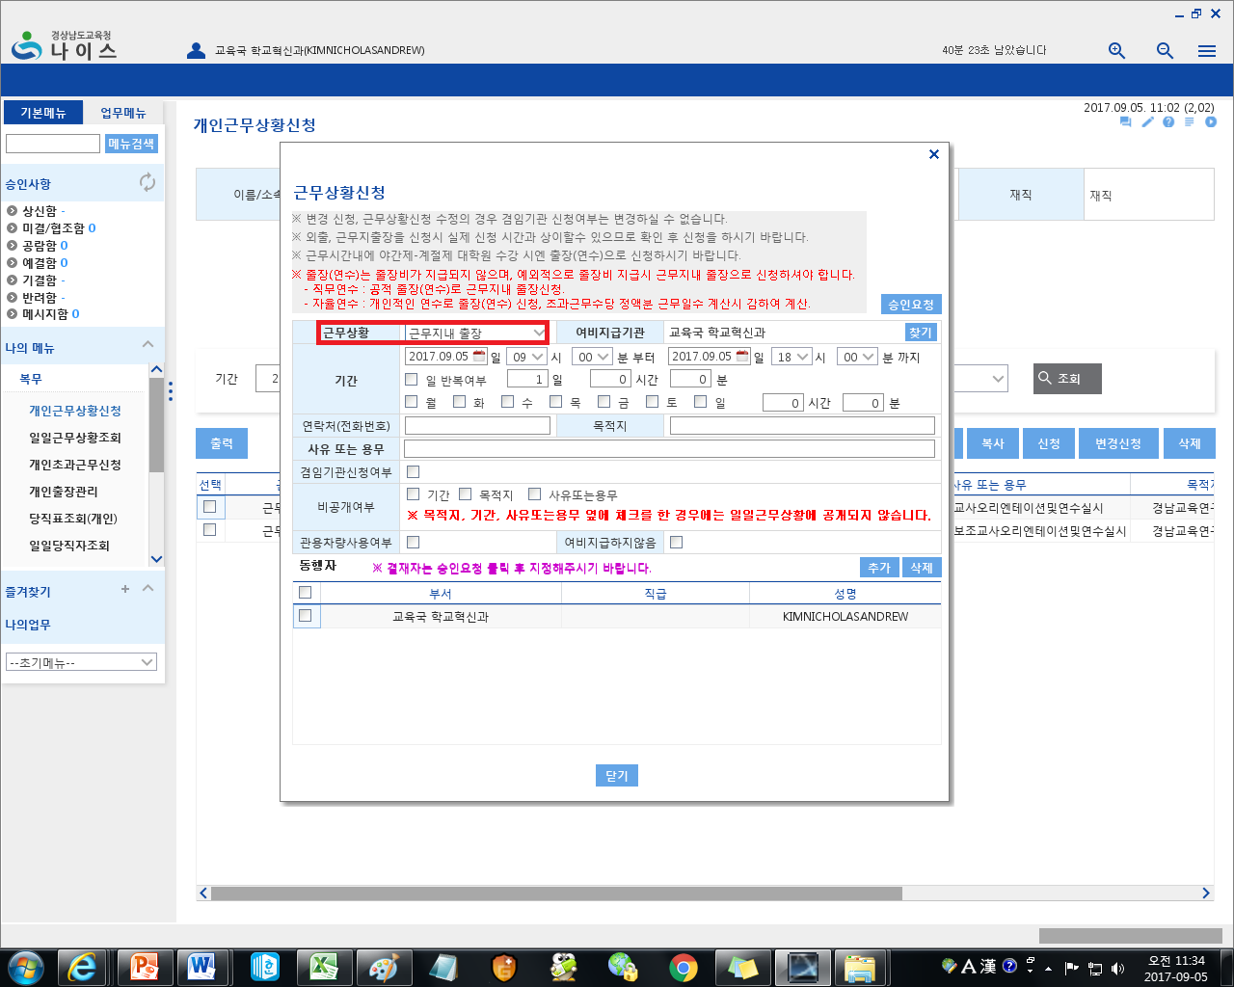

19. Next, you must fill out the highlighted box below.
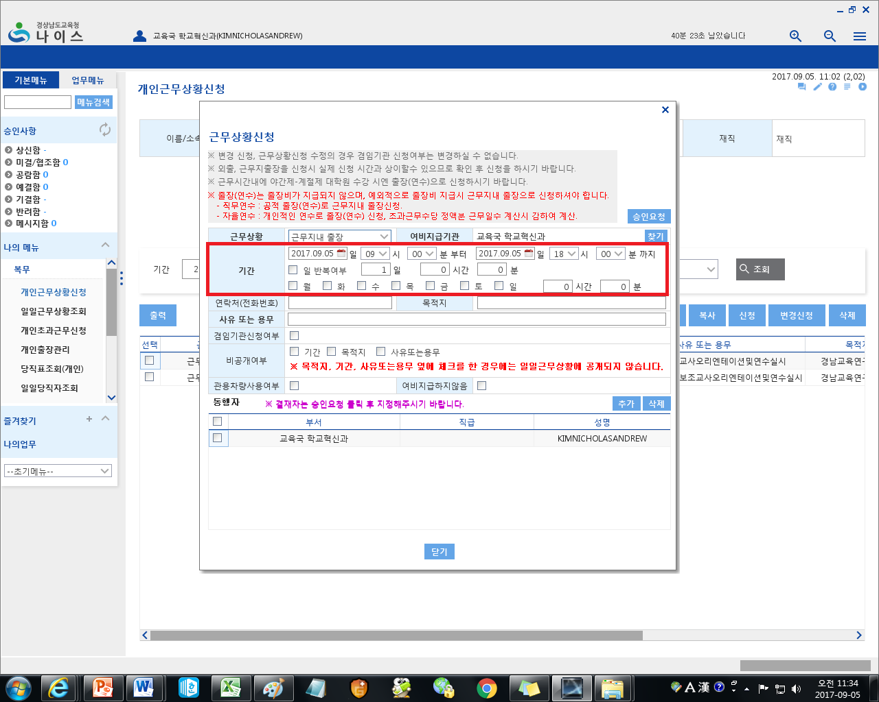
MAGNIFIED:
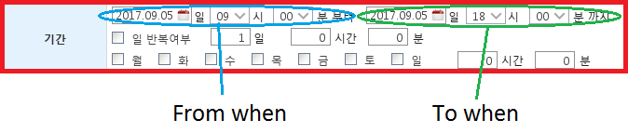
So in our scenario, we will be going to our second school on Thursday (let’s say its November 2nd). So we click on the calendar for the blue circle, and select November 2nd. Then for the time, change to whenever your school starts, usually 9:00 KST (Check with your co-teacher to make sure it’s right as it may be different from school to school). Then for the green circle, for date, again, click on the calendar and select November 2nd. Then for the time, as you will be at the school all day, ending time for most schools is 17:00KST or 5:00PM, so change the time to reflect that.

20. Then fill out the box that says 연락처(전화번호) [Yeon-Lak-Chuh(Jun-Hwah-Bun-Ho)] – Phone Number
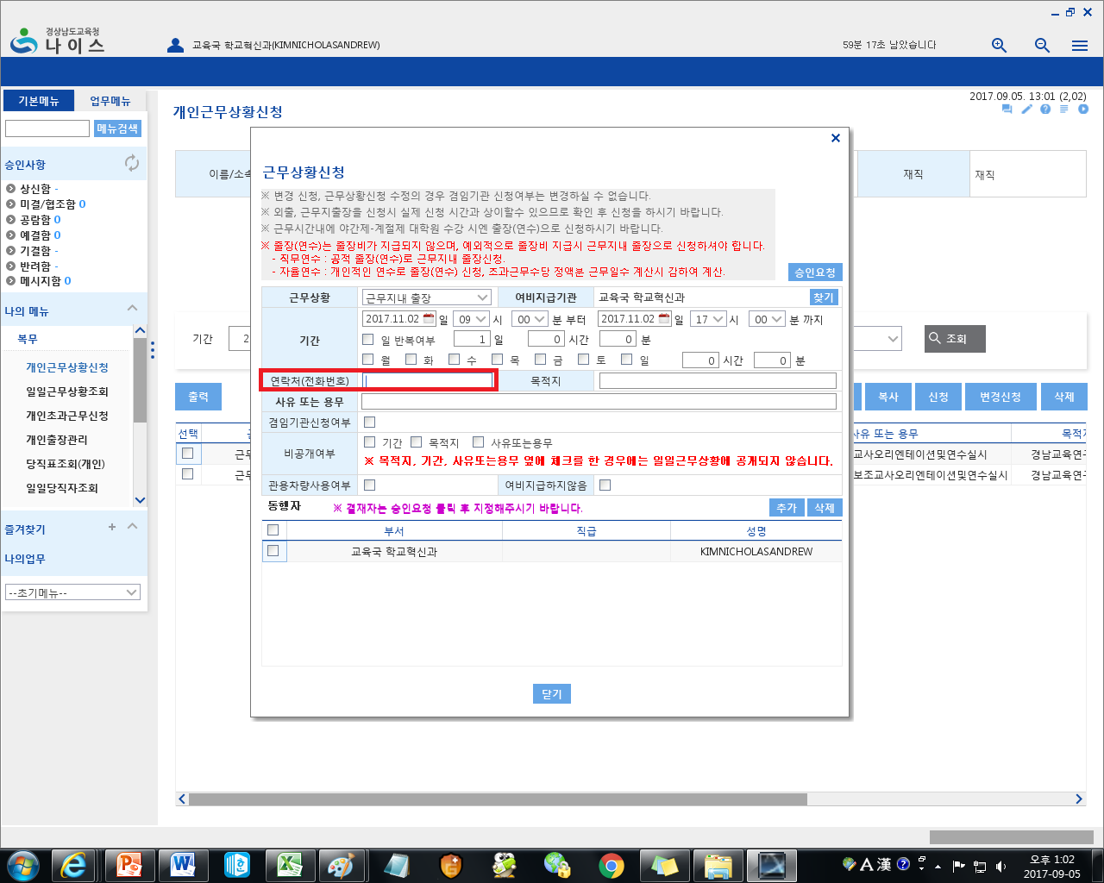

21. Then fill out the box that says 목적지 (Mok-Juk-Ji) – Location. So in our scenario, you would input the name of your second school.
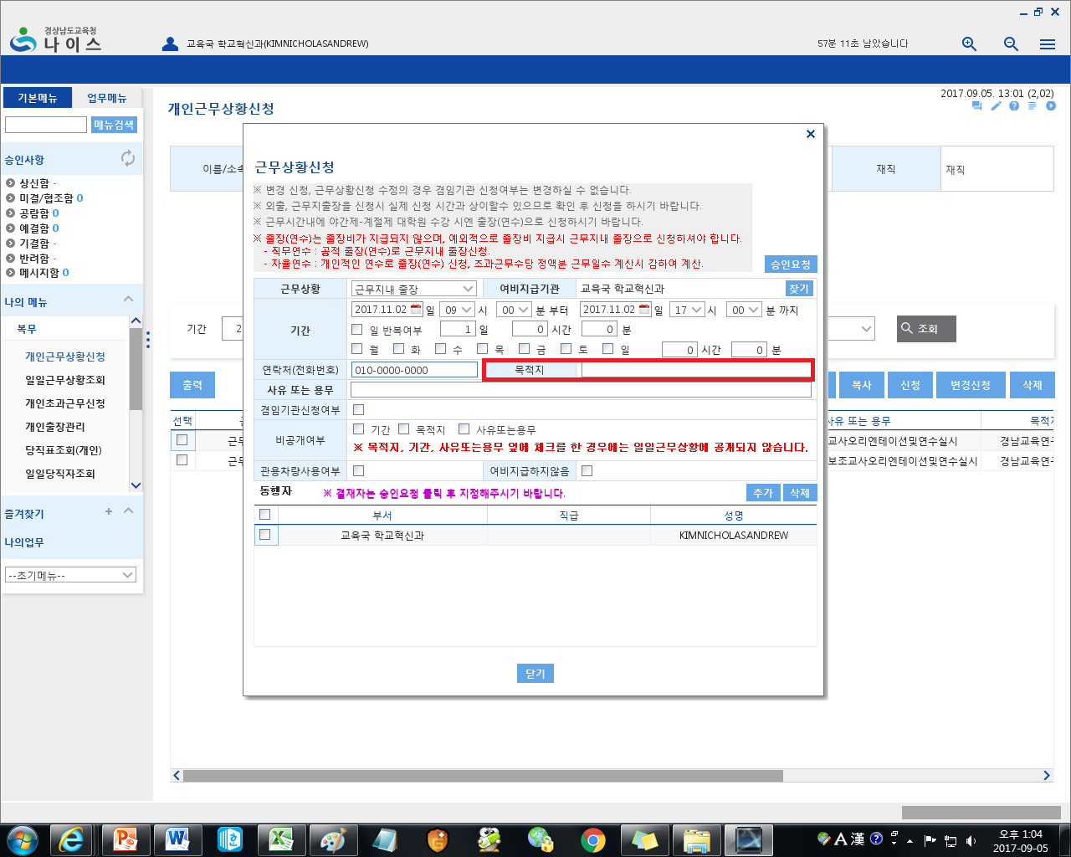

22. Then fill out the box that says 사유 또는 용무 (Sah-yoo Ddo-neun Yong-moo) – Reason. In our scenario you can just write something simple like, ‘Going to secondary school’. (You can write everything in English)
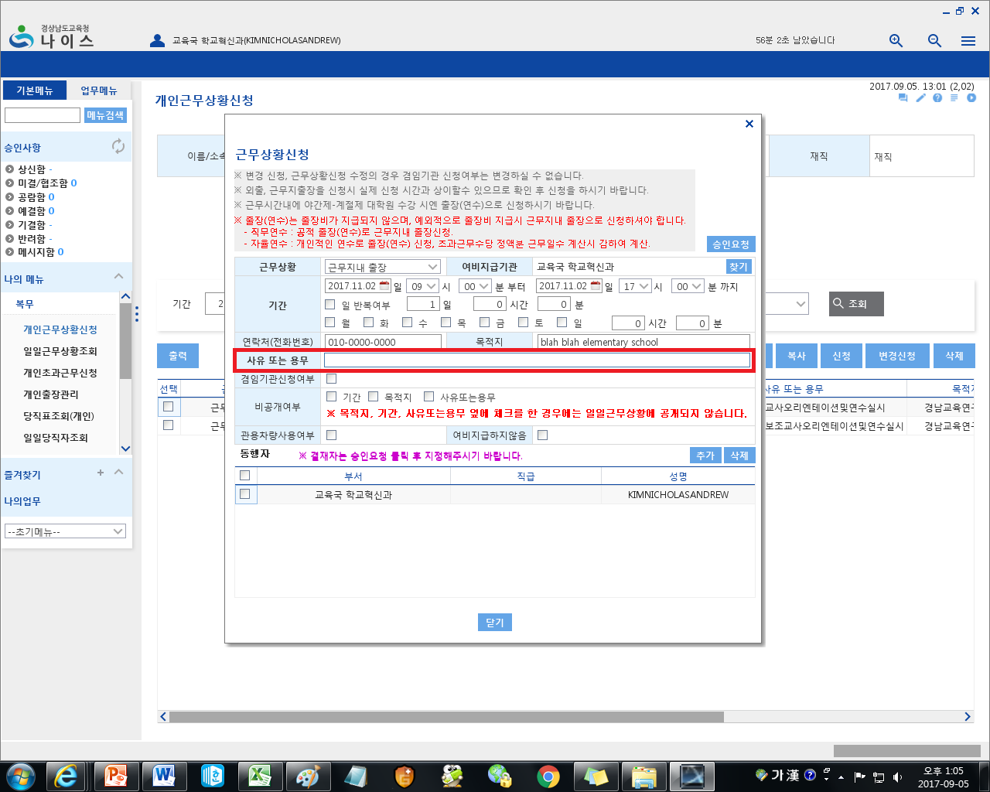

23. For our scenario, when you are going to your secondary schools, you must check the box that says 여비지급하지않음 (Yuh-Bi-Jee-Geup-Ahn-Ham) – No travel allowance. You will already get paid a multiple school allowance and so you do not qualify for travel pay in this instance. Please note that when you apply for this, the document will be sent to your co-teacher and principal for review. It’s best not to mistakenly check the other box as it could lead to a misunderstanding.
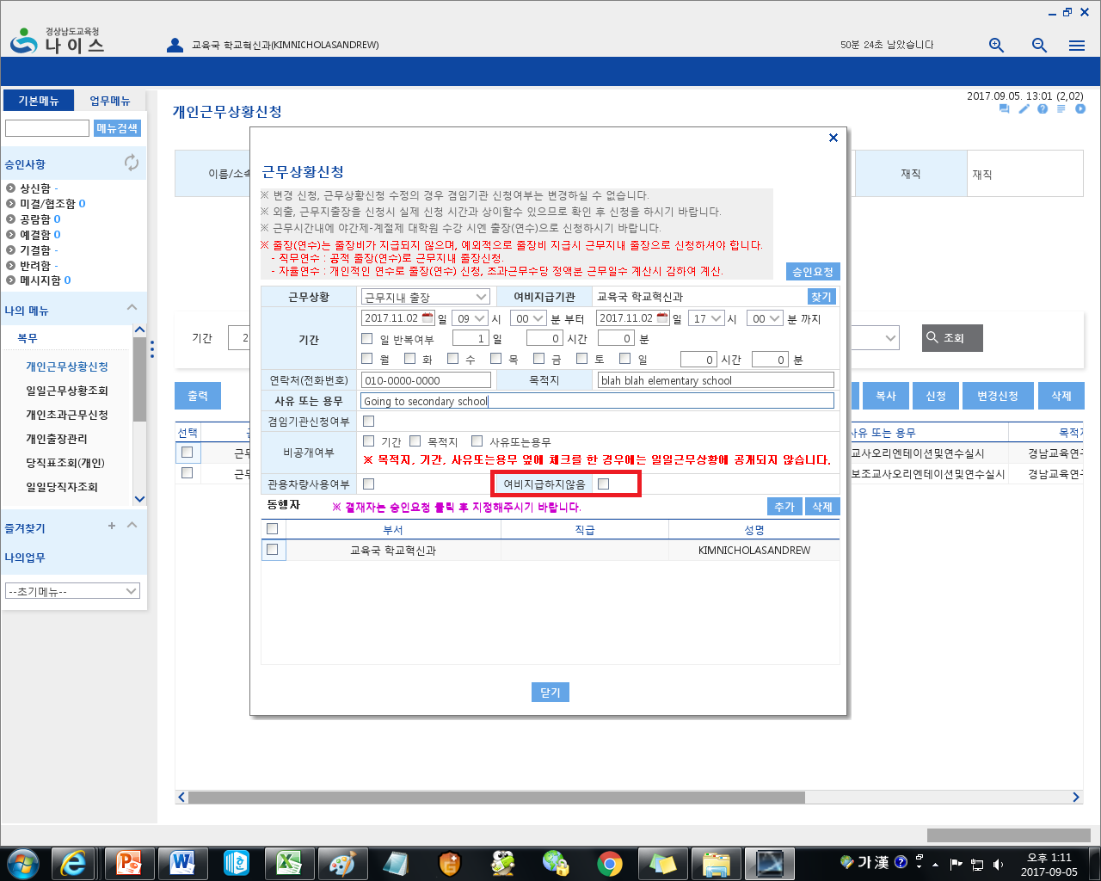

24. When you check 여비지급하지않음, this box will pop-up asking confirmation that you will not receive travel allowance. Just click the blue box that says 확인 (hwa-geen) – Confirm.
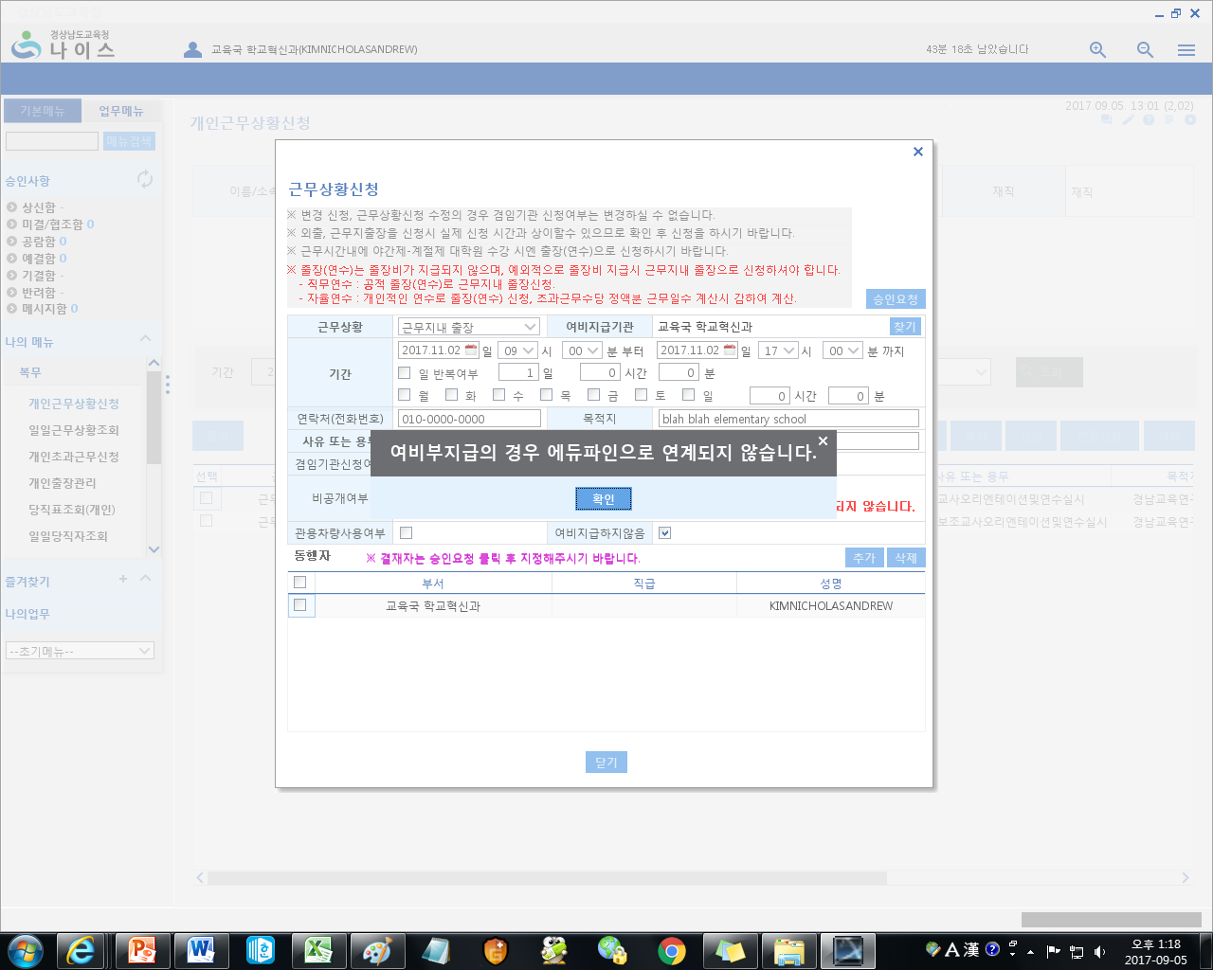

25. Once you have filled in all of the boxes, click on the upper-right most blue box that says 승인요청 (Seung-In Yo-Chung) - Select Reviewer
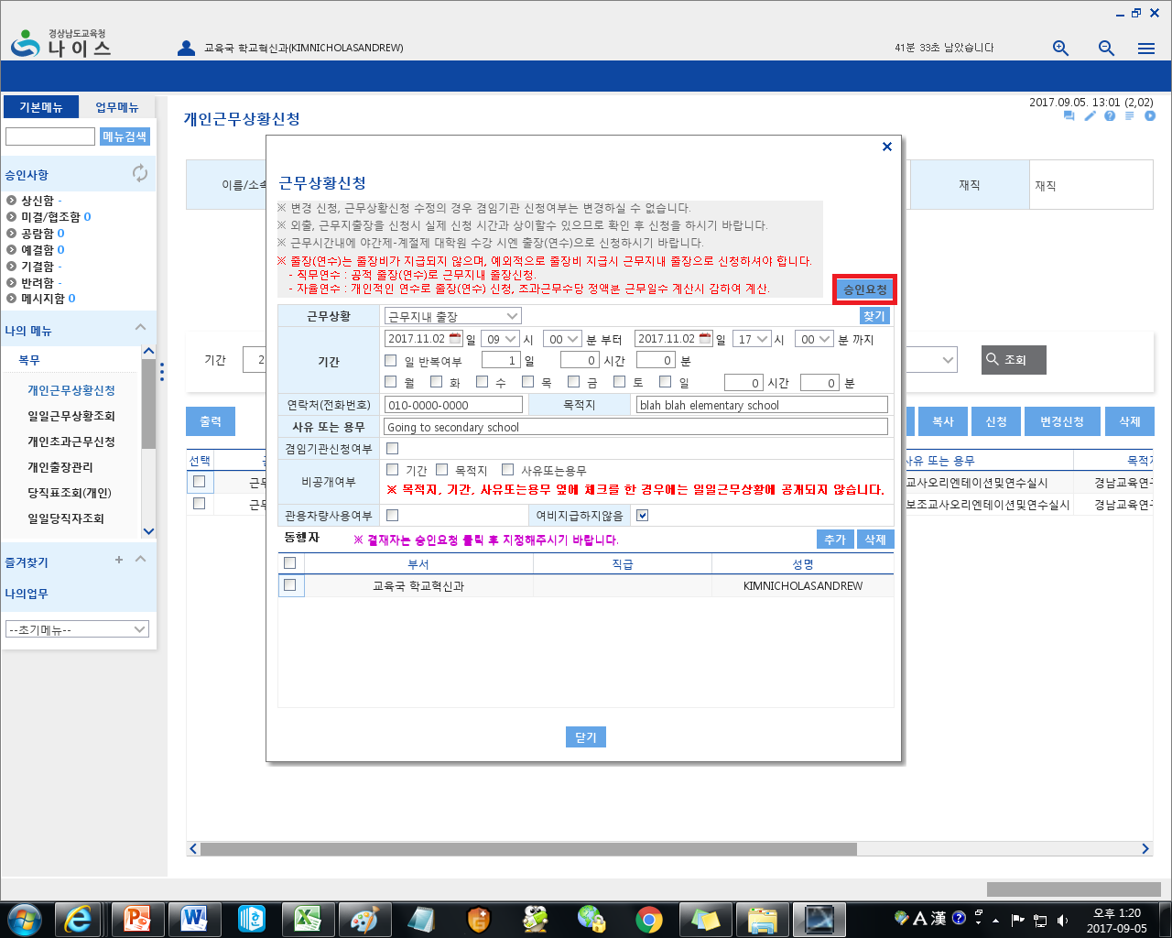

26. Clicking 승인요청 will bring up this pop-up.
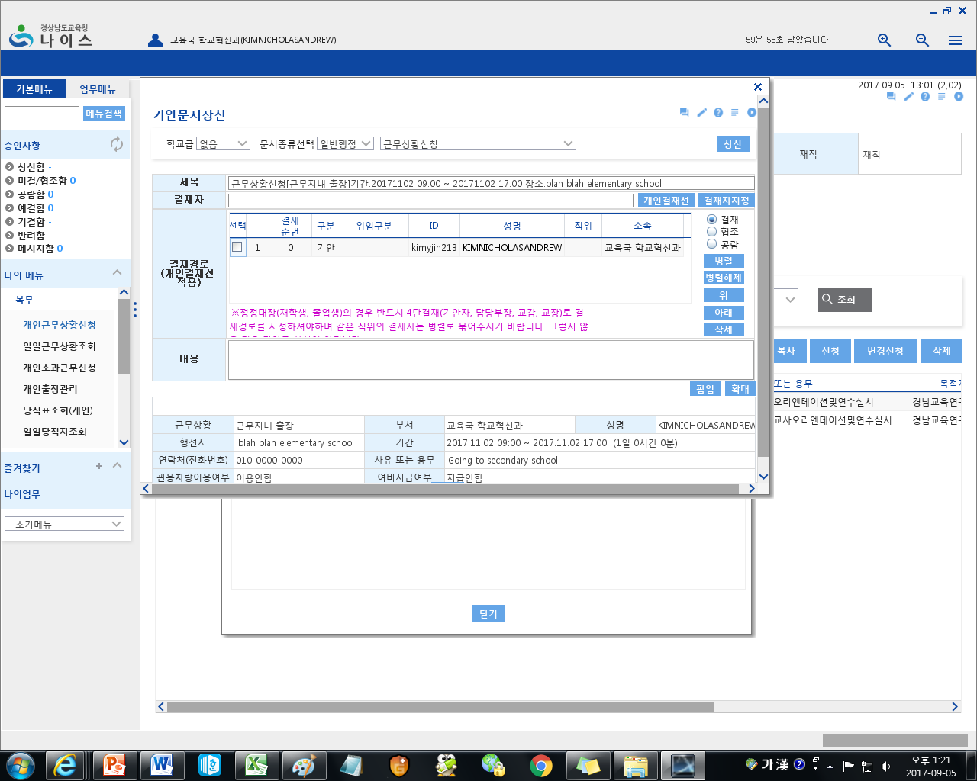

27. Click on 결재자지정 (Gyul-Jeh-Jah Jee-Jung) - Select Reviewer
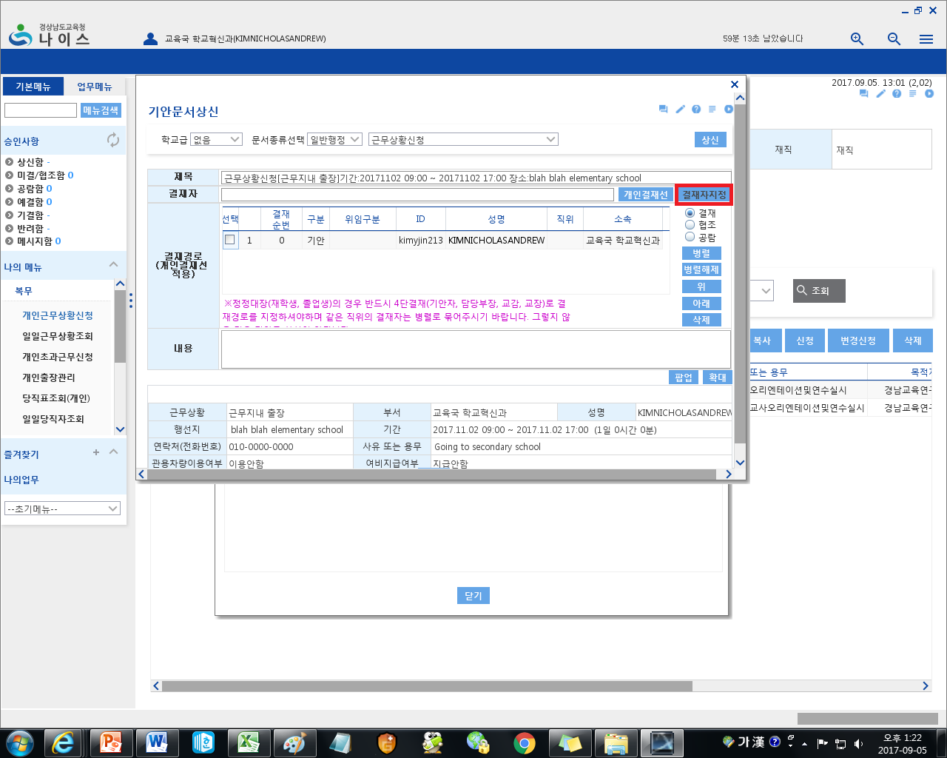

28. Clicking on 결재자지정 will bring you to this pop-up.
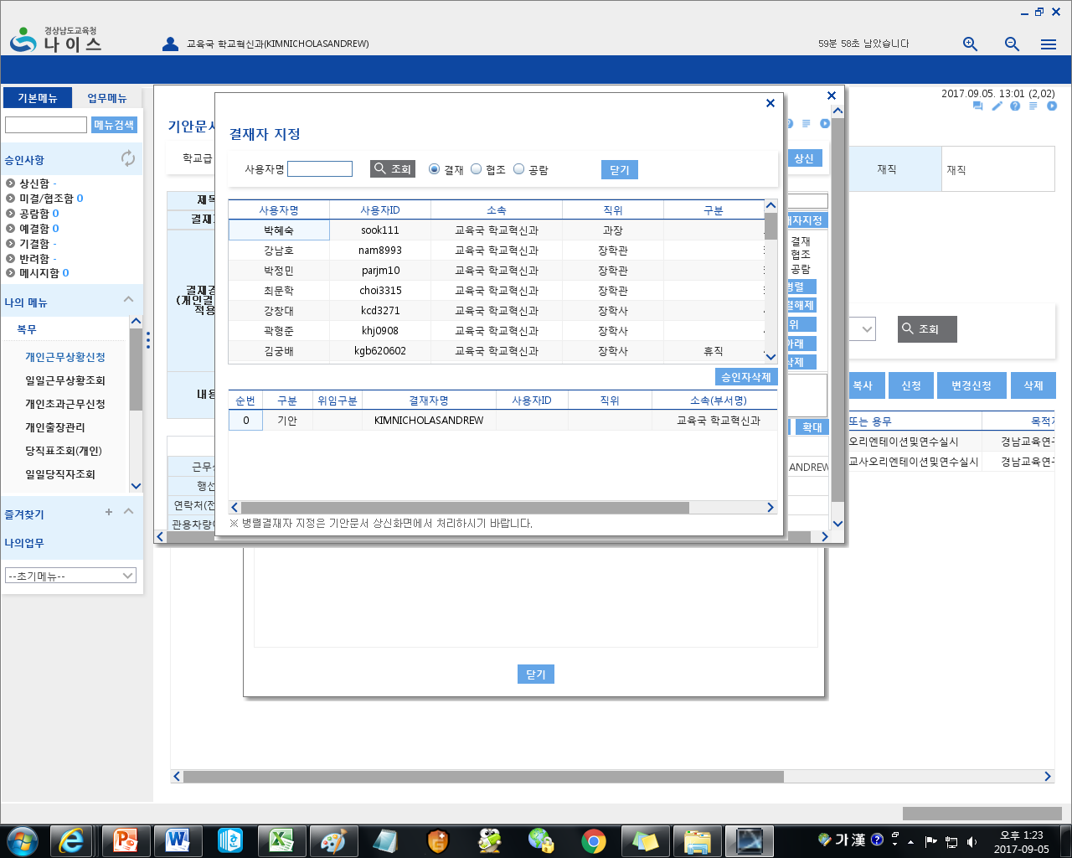

29. Here you will need to learn how to type your main co-teacher’s name and your main schools principals/vice principals name in Korean. (You must attach both your main co-teacher AND your main school’s principal/vice principal. Depending on your school, they may have you attach your co-teacher and your principal, and some schools may have you attach your co-teacher and your VICE-principal. As this can vary, please ask your co-teacher who to send this document to.) Once you have typed a name in Korean, click 조회 (Jo-Hweh) – Search.
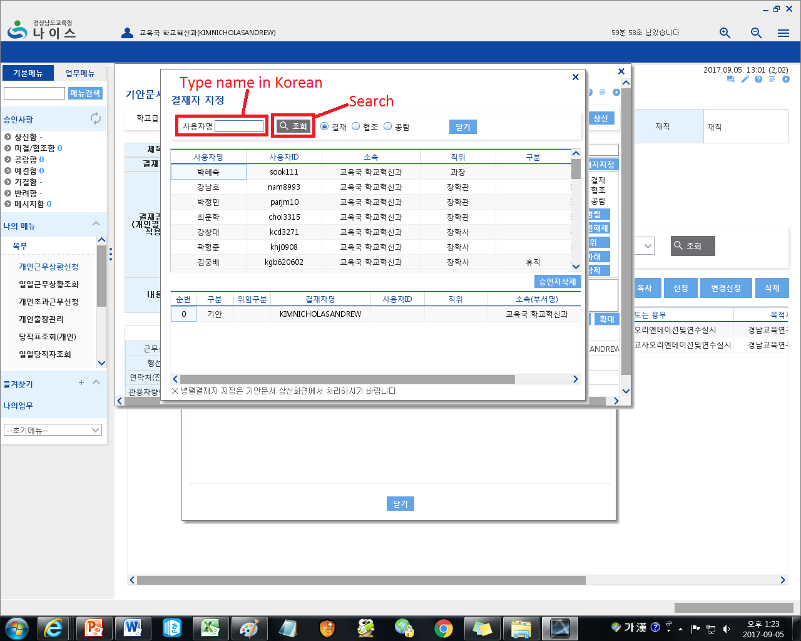

30. Once you type in a name and click 조회, a list of people with that name will pop-up. As was mentioned earlier, this system is used by all of GOE, and so depending on the name, there may be many people with the same name. So after you have input and searched for a person, make sure you look at the person’s place of employment and their title (you may need help with this as it will be in Korean). Then double click that person’s name and it will be added onto the application.
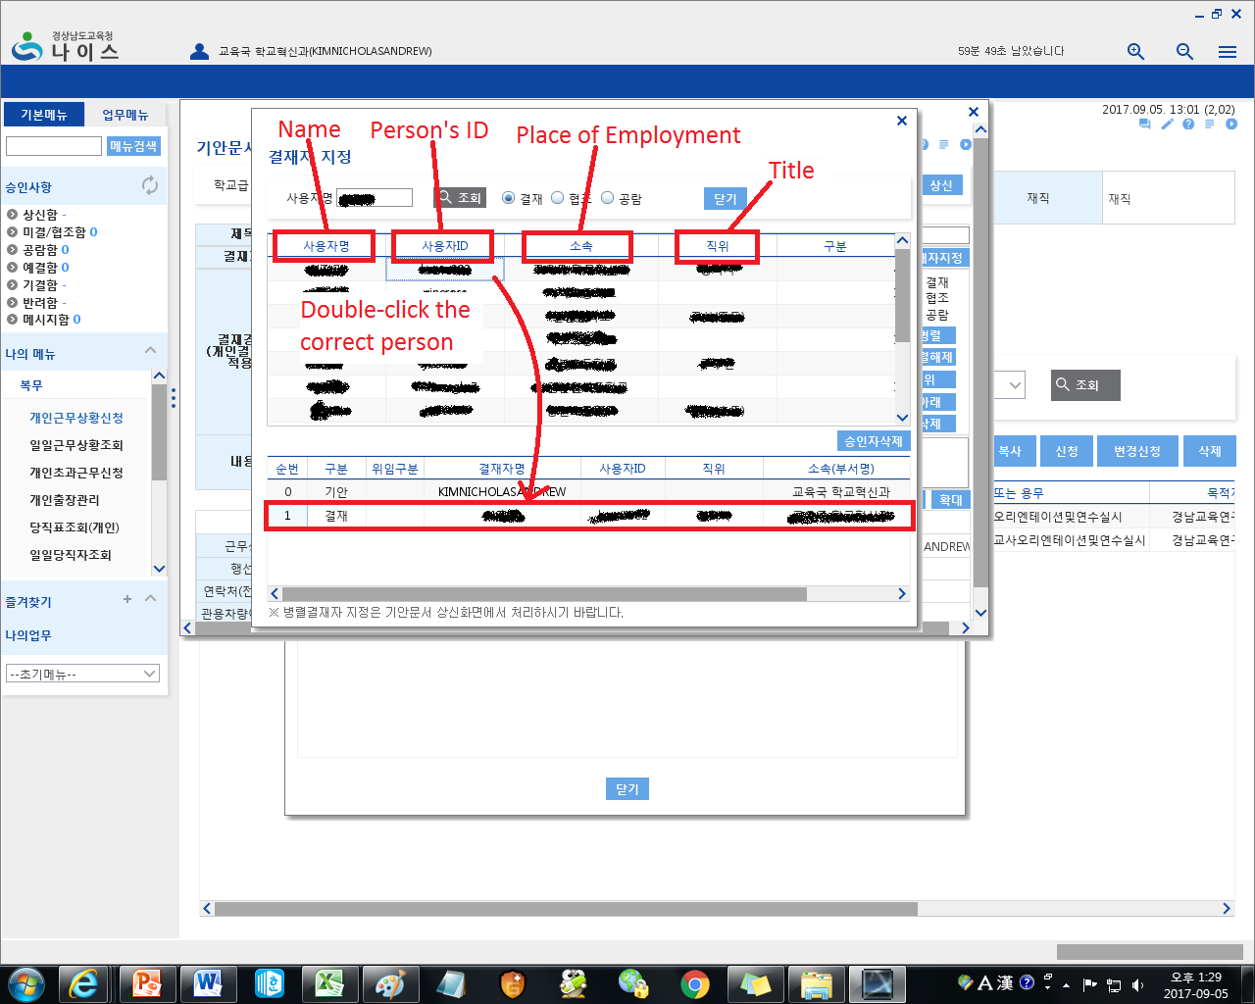

31. Once you have selected both your co-teacher and your principal/vice-principal, click on 닫기 (Dat-gi) – Close, to close the window.
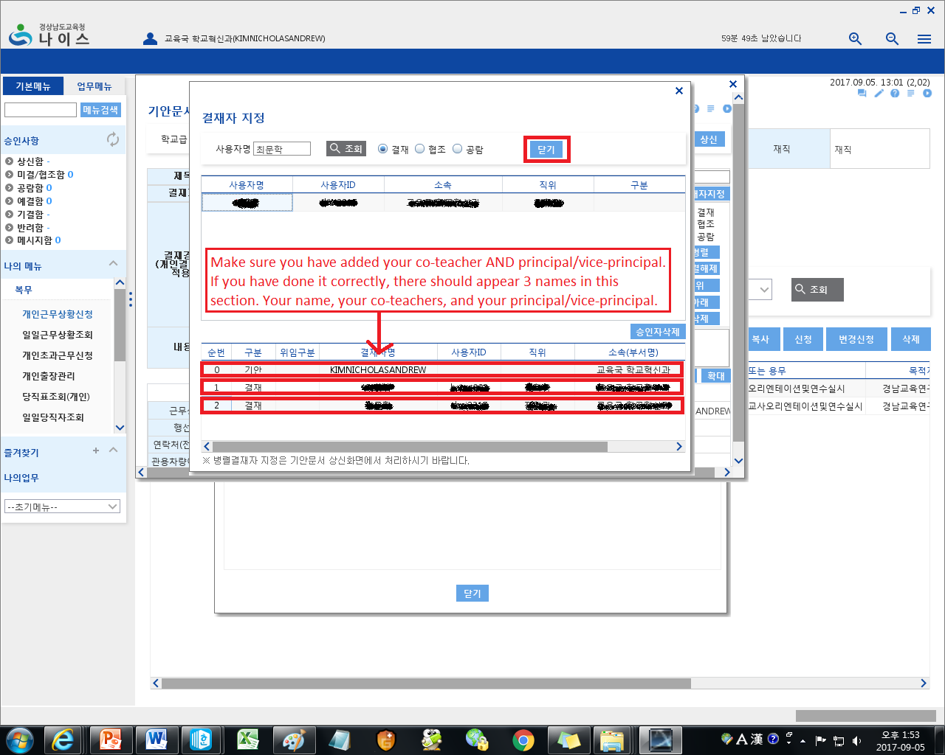

32. Lastly, click 상신 (Sang-Shin) – Report, in this case it basically means upload.
